Andree Salvo
Southern New Hampshire University
CYB 300-14668
6-2 Lab Worksheet
Instructor: Jason Keltner

Lab: Implementation of Automation and Orchestration for Security Operations

Exercise 1: Creating Automation Scripts
Prompt | Response
Task 1: Create a Linux Automation Script: Provide a screenshot of Step 3 showing the creation of 10 text files in the Documents folder. Add your name in the command line. | 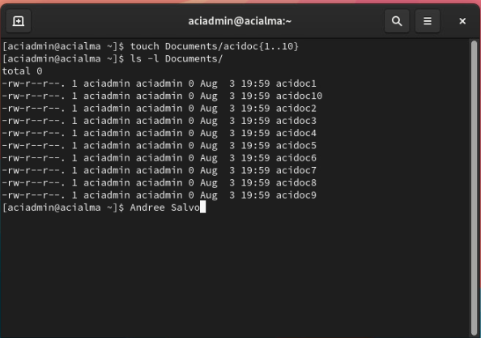
Task 1: Create a Linux Automation Script: Provide a screenshot of Step 5 showing the required command to list the user’s home folder content. Add your name in the command line. | 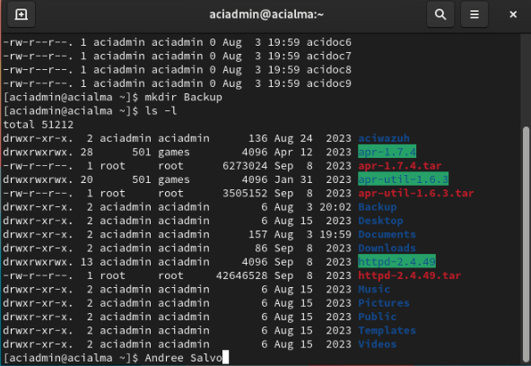
Task 1: Create a Linux Automation Script: Provide a screenshot of Step 13 showing the command displays the properties of the created script file. Add your name in the command line. | 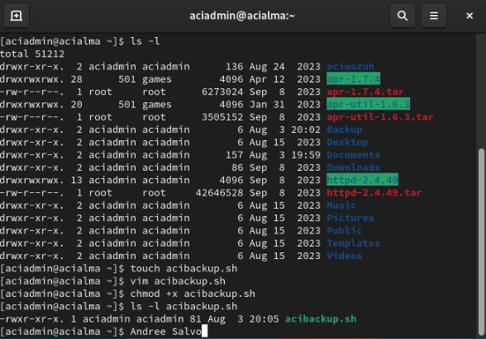
Task 3: Creating Users Using a Script: Provide a screenshot of Step 11 the user “Subi” being successfully created using the PowerShell script in the Active Directory Users and Computers. Bring the Administrator: Windows PowerShell window in front of the Active Directory Users and Computers and add your name in the command line. | 